KNOW, RECKON, PRESENT, OBEY
(Answering 25 Key Questions about Romans 6:1-16)

- What is the context of Romans 6?

- THE RIGHTEOUSNESS OF GOD INTRODUCED – the MESSAGE of the GOSPEL. (Rom. 1:1-17)

- THE RIGHTEOUSNESS OF GOD REQUIRED – Man’s SIN and God’s CONDEMNATION (Romans 1:18-3:20)

- THE RIGHTEOUSNESS OF GOD RECEIVED – SALVATION from SIN’S PENALTY and JUSTIFICATION (Romans 3:21-5:21)

- THE RIGHTEOUSNESS OF GOD REPRODUCED – SALVATION from SIN’S POWER and SANCTIFICATION (Romans 6:1-8:17)

- What are some important observations to make about this section?

- Paul has settled the issue of justification by grace and eternal security _________ he discusses your Christian walk.

- Note the striking contrast between ________________ and _________________. (5:12-21)

- Paul sees God’s plan for you as a believer in 3 stages: _________________________ (3:21-5:21); ______________________________ (6:1-8:17); and ______________________________ (8:18-39).

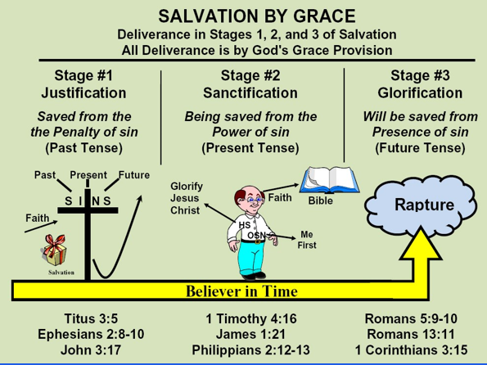

- What logical question should you anticipate if you preach the Gospel of grace clearly? (6:1a)

- What is the emotional answer to this anticipated objection? (6:2a)

- What is the theological reason a believer should no longer live in sin? (6:2b)

- What is “sin” normally referring to throughout Romans 6-8?

- When did you die to sin? (6:2)

- How did you die to sin? (6:3)

- What does the word “baptized” mean and refer to? (6:3)

- What was the purpose of your co-crucifixion, co-burial, and co-resurrection with Christ? (6:4-5)

- What does God now want you to know? (6:6a)

- What is the “old man” referring to? (6:6a)

- Why would God “crucify the old man” with Jesus Christ? (6:6b)

- Because of the cross-work of Christ and your position in Him, what are you no longer? (6:6c)

- What does this mean practically about you living any longer in sin? (6:7)

- In addition to knowing that you died with Christ, what does God want you to believe about living with Christ due to your identification with Him? (6:8-10)

- What is the first imperative in Romans regarding the daily Christian life? (6:11)

- How does one “reckon”? (6:11)

- What are you to “reckon” to be true because it is? (6:11)

- What does vs.12 indicate about your sin nature yet? (6:12)

- In contrast to presenting yourself or your members to the sin nature to reign, what should you repeatedly do from day to day? (6:13)

- How is the Christian life not to be lived? (6:14a)

- How is the Christian life now to be lived? (6:14b)

- What principle must you remember and two options that you have each day? (6:15-16)

- What are the 4 key words in this passage and their logical order?

